World Happiness Report Broad Scope Analysis

*Patrick Meyer, Ujjwal Samanta, Tipu Sultan*

***Abstract*** — This paper provides a general overview of the World Happiness Report and its dataset, by analyzing a mixture of some of the more general trends present, such as the global correlation between happiness and GDP, as well as a closer look at the happiest Country, Denmark, and how GDP, social support, and positive affect play a role in determining a country’s Happiness Index.

# INTRODUCTION

An entire decade has passed since the inception of the World Happiness Report (WHR), as such there is no better time to celebrate the tremendous insight it has provided. The WHR is an annual publication that attempts to rank a nation’s happiness based on the respective country’s citizens’ individual responses on the Gallup World Poll1. Other economic, social, political, and cultural factors are also a part of the poll, such as GDP, life expectancy, confidence in government, etc. The results presented in the WHR should merely be considered to provide *some* scope into what, how, and why each country’s happiness varies so. It is not a be-all and end-all survey defining what creates happiness, and this report will not treat it as such either.

1 “FAQ.” *Home*,

# PREVIOUS WORK DONE BY OTHERS

Naturally, the WHR has its own report and findings that are published annually in great detail. The WHR’s report typically focuses on a yearly theme, with the theme of their latest report revolving around COVID-192. Their reports do an excellent job of providing a balanced analysis with their datasets by considering things such as using weighted population, which removes any biases that raw cumulative data might provide. Moreover, due to their experience with the dataset they are also able to consistently highlight, explain, and relate outliers from over a decade ago to patterns found in more recent data. In line with their meticulous nature is their division of continents into further sub-regions, such as South Saharan Africa, which would more accurately represent differences across regions that are a result of cultural and geographic divide. This paper will take a much broader approach to the dataset that will, hopefully, produce much more generalized trends that allow for a more *accessible* analysis that might not be as dense as WHR’s.

2 Helliwell et al.

# DATA SOURCE DETAILS

As mentioned previously, the dataset is acquired through the Gallup World Poll, and is available in its entirety through the WHR. The dataset contains data from 2007 until 2021; in 2007 only 24 countries had data recorded, whereas in 2021, 116 countries had recorded data. The categories of data are:

* Life Ladder
* Log GDP per capita
* Social Support
* Healthy life expectancy at birth
* Freedom to make life choices
* Generosity
* Perceptions of corruption
* Confidence in National Government
* Positive/Negative Affect

Life ladder is the equivalent of the happiness index/score and will be used interchangeably; participants are asked to imagine they are climbing a 10 step ladder, where the final step, 10, is the best possible life, and, 0, being the worst possible life3. To contextualize this number further, Gallup considers a rating of 4 or lower to be ‘suffering’, and a rating of 7 or higher to be ‘thriving’4. The reason the log of GDP is taken is so that the change in GDP can be seen as a continuous percentage change - it can be plotted in a linear fashion. Social support, freedom to make life choices, generosity, perceptions of corruption are all the averages of binaryresponses to simple questions regarding each respective category, i.e. “Are you satisfied or dissatisfied with your freedom to choose what you do with your life?”5 Positive and negative affect are a measure of laughter, enjoyment, learning, and worry, sadness or anger6, respectively. As for missing data, despite GDP being readily available through other sources, countries with a history of political turmoil such as Taiwan, Somaliland, Kosovo, Hong Kong, North Cyprus, and Afghanistan did not report their GDP across several years. A disproportionately large amount of Asian and African countries also are missing data for perceptions of corruption, freedom of life choices, as well as confidence in national government - this could be due to the fact that some of these measures are, typically, Western, liberal ideologies. Lastly, the respective continents of each country had to be added manually to the dataset through a VLOOKUP function and another geographical dataset.

# RESULTS,

**INTERPRETATION, DISCUSSION & COMPARISON**

Figure 1 is representative of the big picture that the WHR is painting. At first

3 “FAQ.” *Home*,

4 “In U.S., Poor Life Ratings Reach Record High.”

*Gallup.com*

5 Helliwell et al.

6 Ibid

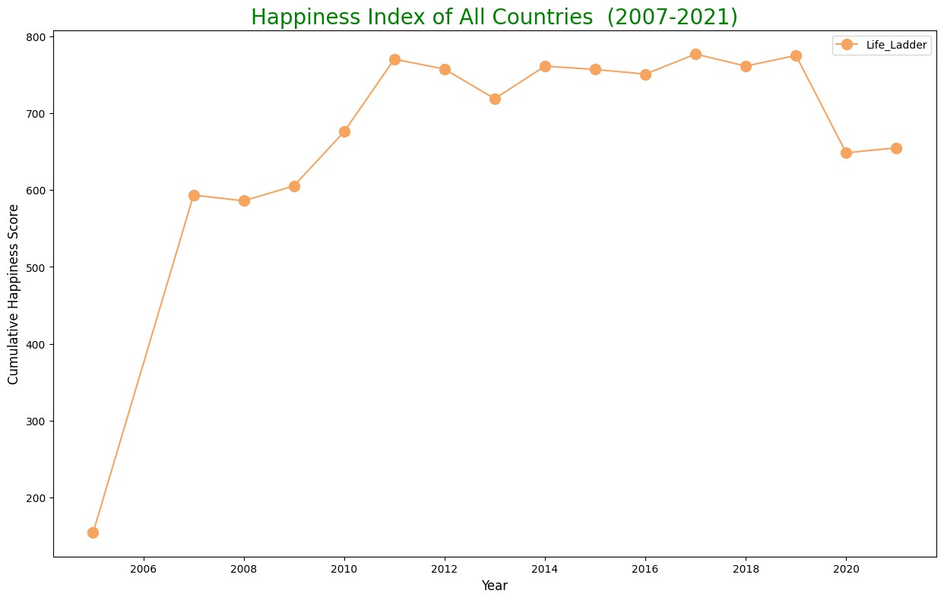

glance there is a clear positive trend during the late 2000’s, however, the large jump is best explained by the increased participation of countries, rather than a dramatic increase in global happiness. In 2008, only 108

countries participated, in 2009, 111 countries, in 2010, 123 countries, and finally in 2011, 142 countries participated, which is the same count as in 2021.

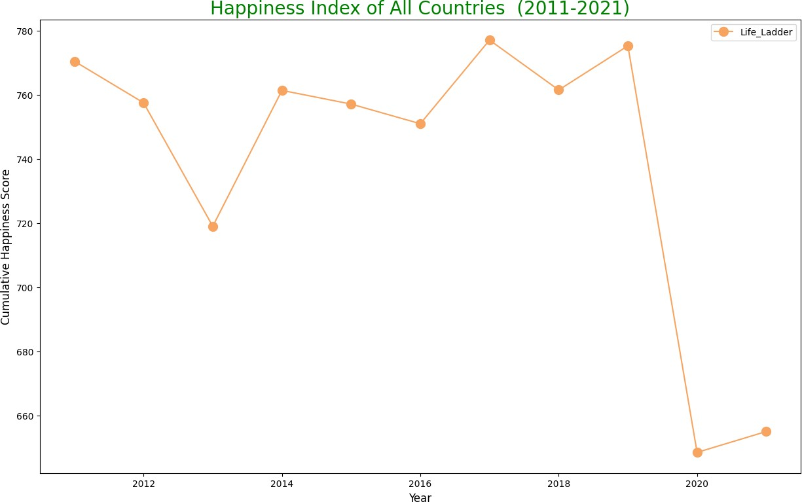

In figure 2 only the happiness scores after 2010 are considered. Despite being

within a smaller range of the y-axis, the fluctuations within this graph are a lot more

worthy of analysis. The two most critical points are 2013 and 2020, both of these years featured significant drops in happiness, especially in 2020. It is not

surprising that alongside the growth of globalization, the ubiquity of news outlets has led to the spread of negative news items, which inherently negatively influence consumer’s perception of the current state of the world7

.

Just to name some of the major events that occurred in 2013 which might explain the reduction in happiness include the ongoing Syrian Civil War8; the Ebola virus outbreak9; the Boston Marathon Bombing10. In 2019, global events such as Trump’s impeachment11; Hong Kong’s pro-democratic protests were met with extreme retaliation from the Chinese government12; ongoing Brexit situation in the EU13; are all events that have caused divide in North America, Europe, and Asia. A specific breakdown correlating reductions in happiness with negative global news is beyond the scope of this paper but would generate a worthwhile discussion elsewhere. One can only hope that within the next few years that the happiness index, at the minimum, reaches the range of 760 and 780

7 “The Psychological Effects of TV News.”

*Psychology Today*

8 “Syrian Civil War Fast Facts.” *CNN*

9 Coltart, Cordelia E M et al.

10 “Boston Marathon Bombing.” *History.com* 11 “President Donald Trump Impeached.” *History.com*

12 “Hong Kong Protests: Updates and Latest on City's Political Unrest.” *CNN*

13 Castle, Stephen, and Steven Erlanger. “E.U. Approves Brexit Extension, but Chaotic Departure Still Looms.” *The New York Times*, The New York Times

again. One of the major limitations of analyzing this trend other than the generalized nature is that there is not an accurate way to judge during which time of year the surveys were taken and what news events were ongoing.

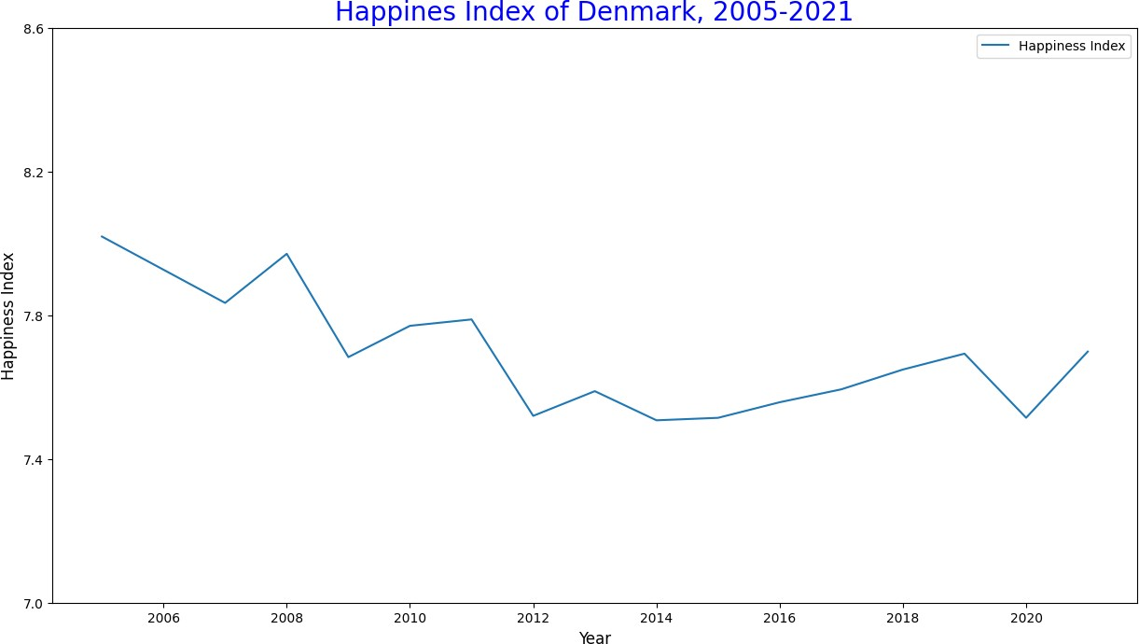

In order to generate a more accurate image of trends in happiness, it is better to look at figure 3, which features the top 20 countries with the highest average happiness score across the past 14 years. Figure 3 reveals the countries that have most consistently ranked highly in terms of the happiness index - at the top are

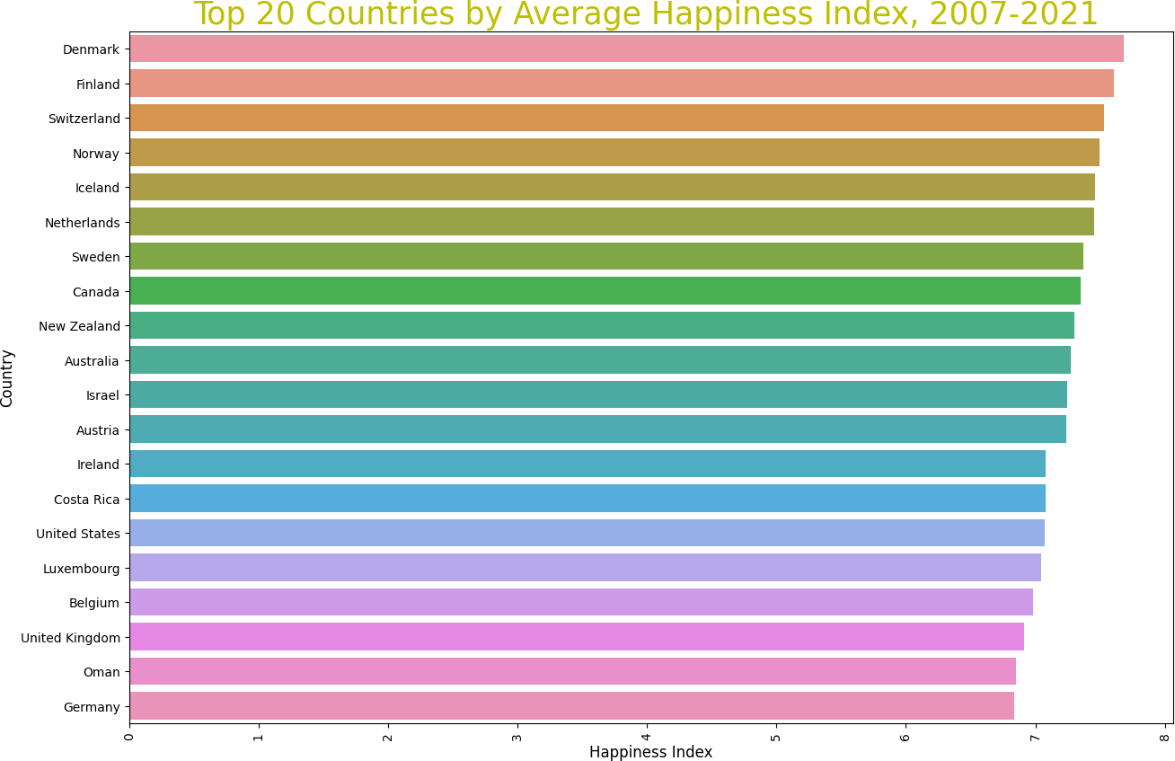

Denmark, Final, Sweden, and Norway. Denmark will therefore be this paper’s country of interest as it is the ideal standard with which to compare other categories to - in hopes that other countries may also attain a greater happiness score by emulating Denmark.

Figure 4 does not need much detailed explanation, however, it is important to compare this with figure 2, which is highlighting global trends. Note that although the dip in 2011 for Denmark matches that of the global dip in 2011 seen in figure 2, in 2019, Denmark’s happiness index decreased less than it did in 2011, as opposed to in figure 2, which saw a much more significant drop in 2019. This is curious because it would suggest that, somehow, Denmark was able to dampen global negative externalities and might reveal the answer as to why Denmark has been able to sustain its happiness. Figure 5 shows the rate of change of GDP and is a classic metric for measuring a country’s economic performance. In this case when compared with the Happiness Index and its changes, there are matching downturns in 2009, as well as 2020. Following the bounce back in GDP growth rate in 2010, the Happiness Score also saw an upturn in 2010. However, as GDP growth rate grew steadily between 2012 and 2018, Happiness did not begin to grow again until 2015. These contradicting trends might

suggest that drastic changes in GDP have an influence on Happiness, whereas slight changes in GDP growth do not have an impact. Since GDP does not seem to have an extremely strong correlation with happiness, perhaps the positive affect, which is more about attitude rather than tangible output, might be a greater indicator for the Happiness Index.



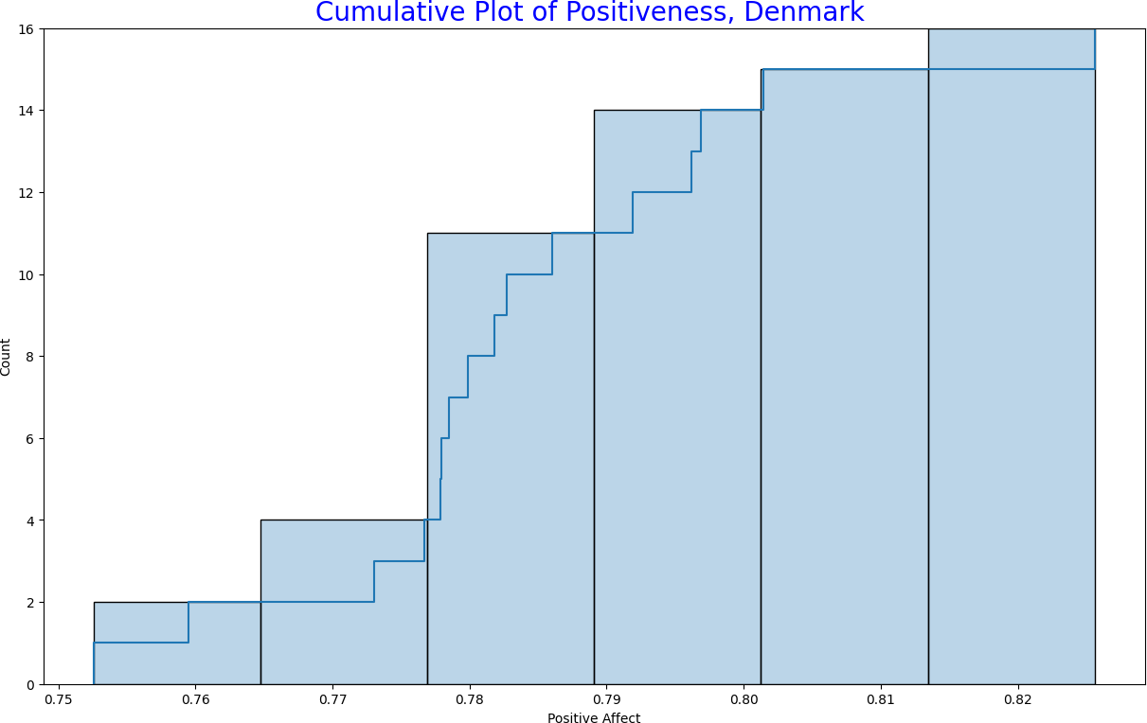

Figures 6 and 7 are empirical

cumulative distribution function plots which show a kind of frequency distribution of where the average Positive Affect response lies. It can be seen that the people of Denmark are

almost 0.3 degrees more likely to induce laughter, enjoyment or learn/do

something interesting than the least happiest countries.

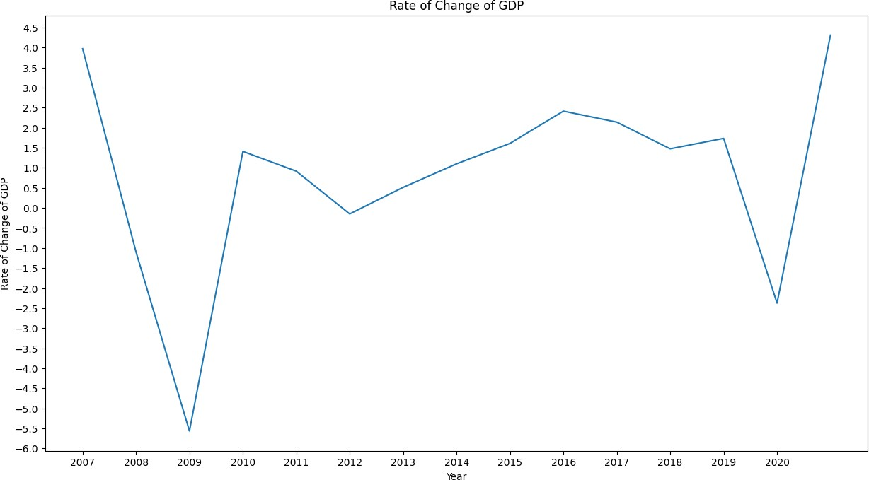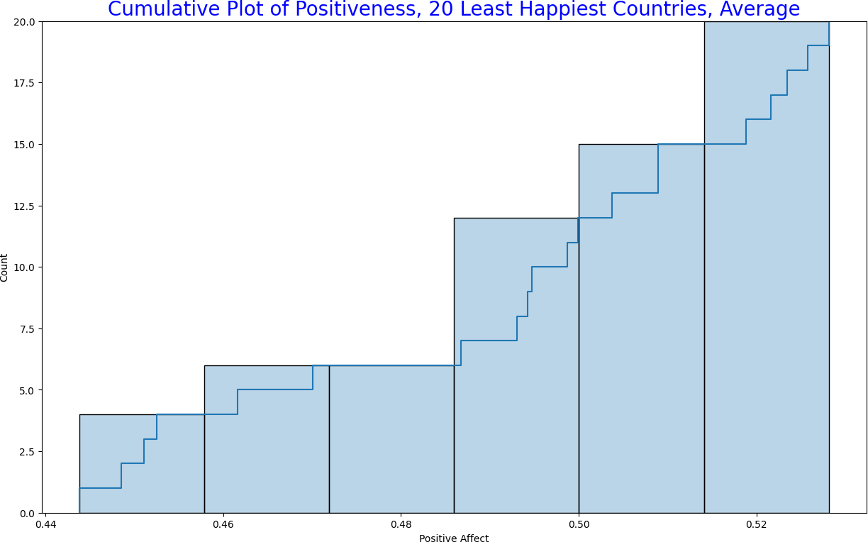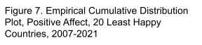



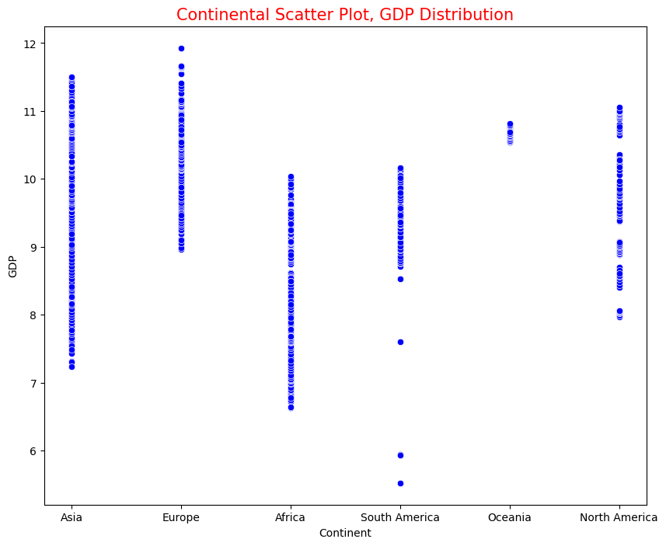

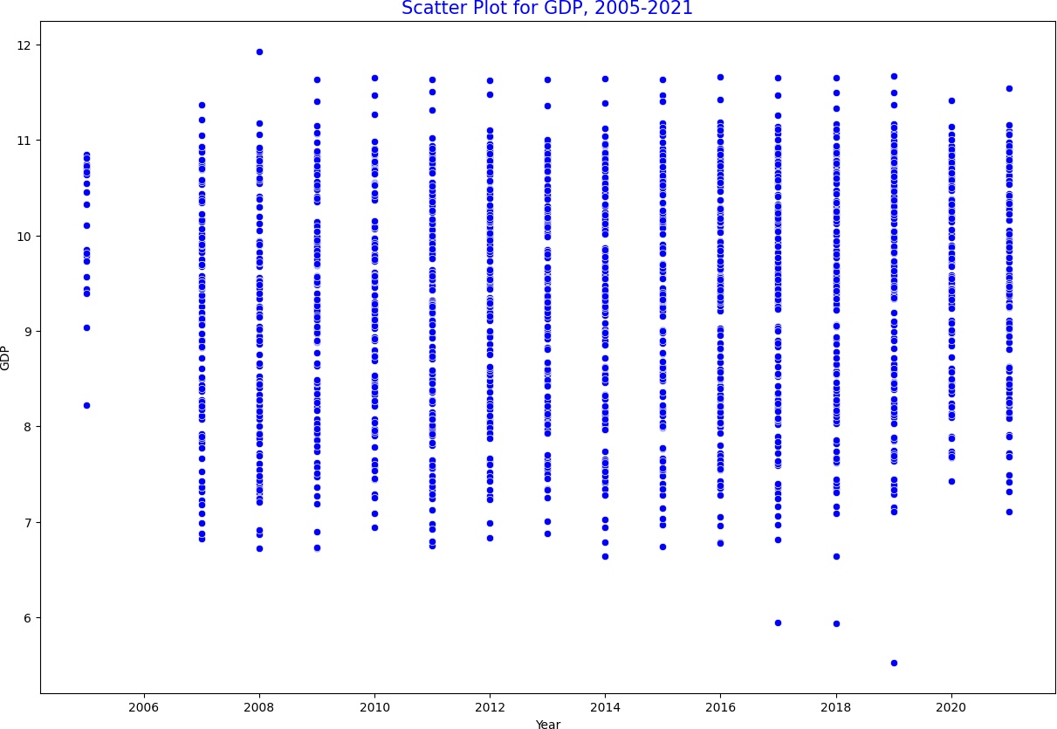



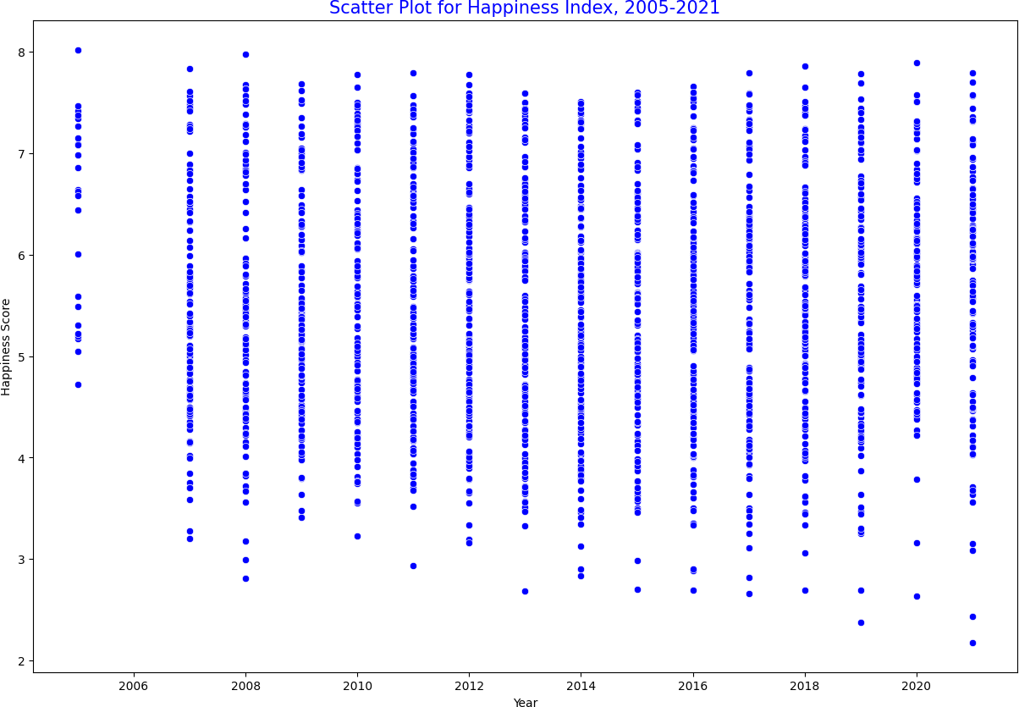

Figures 8 and 9 offer another generalized overview of how GDP might influence Happiness Score, as the dataset is so large here it is important to notice that the outliers at the top of fig. 8 do not quite match the outliers near the top of fig. 9;

whereas there are a lot more distributions of outliers near the bottom of both figures. This fits the idea that once a minimum amount of GDP has been reached, it no longer has a large impact on Happiness. Before this

threshold is reached, however, it could be one of the more important factors in determining Happiness.

Figures 10 and 11 use the same dataset, instead it is organized by continents to give a large-scale global comparison. Of interesting note are the Asian countries

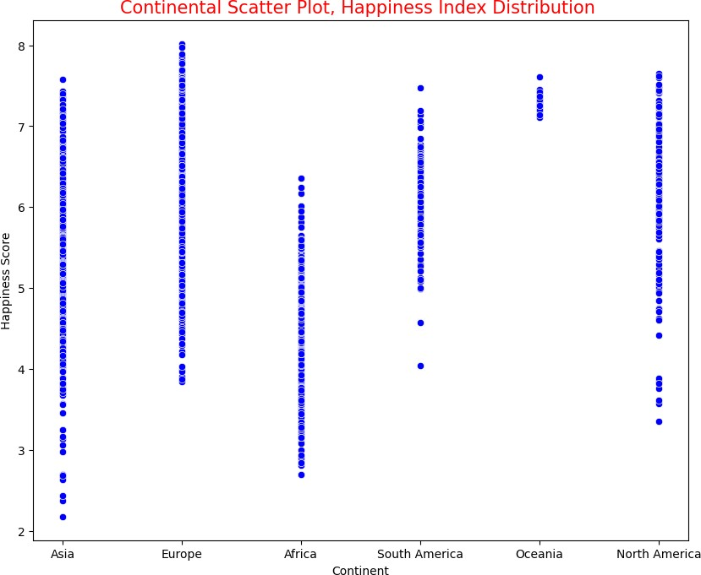

whose Happiness Index almost spans the entire scale between 2 and 8, while their GDP is rather competitive and compactly spread.

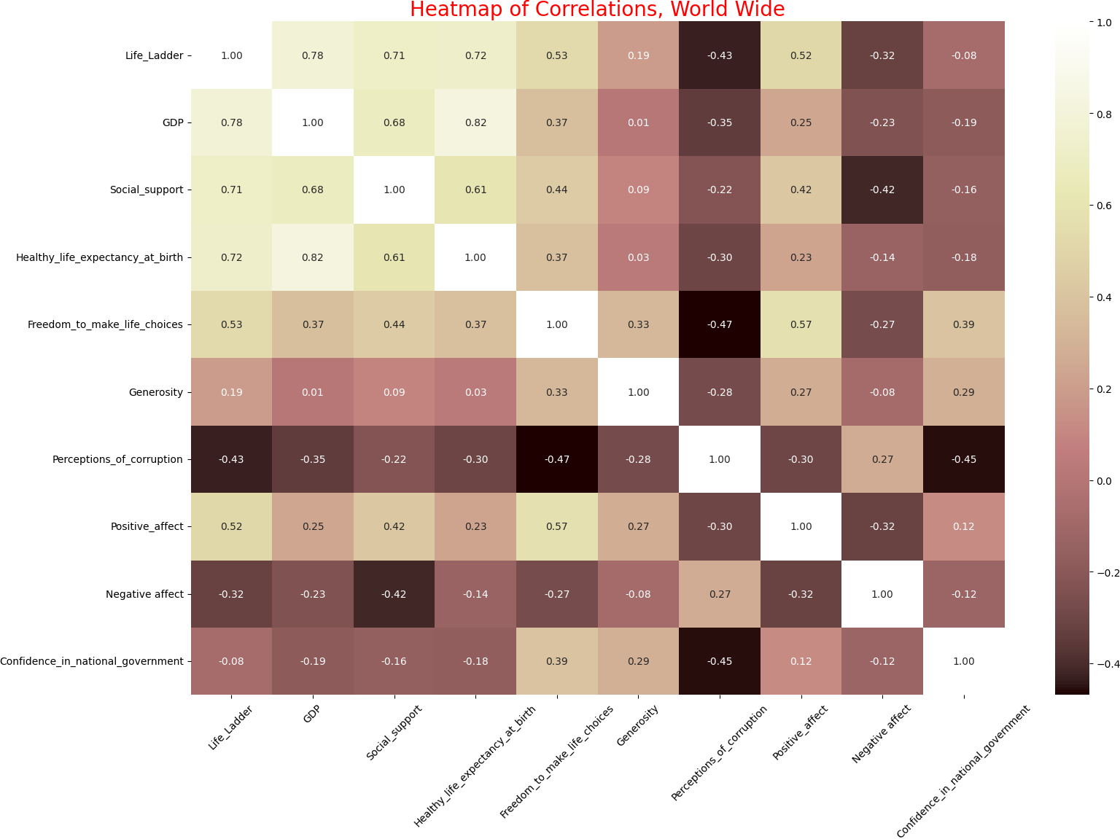

Figure 12 provides the ideal

overview due to all the attributes being on display at once and giving a glimpse into their correlation. The most insightful portion of this graph is the top left quadrant where most of the lighter zones are - this strongly

suggests that GDP, social support, and healthy life expectancy at birth are of the more important values when determining Happiness Index.

Figure 13 below focuses on the just the continent of Europe, which is important as previously it had been mentioned how

several factors follow very Western ideals as well as the fact that

dividing by continents accounts for *some* cultural differences. This acts as more definitive proof as to whether Denmark, specifically, is unique in its Happiness or

whether the entirety of Europe is. Figure 13 does reveal that several Scandinavian

countries (Denmark, Finland, Sweden,

Norway) dominate the average Happiness Score as they hold 4 of the highest scores, alongside Austria, Iceland, Ireland,

Luxembourg and Switzerland. This brings to light a very real trend that, for some reason, Scandinavians are extremely happy relative

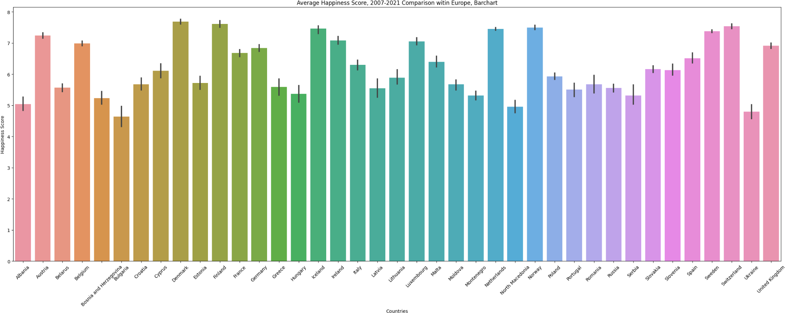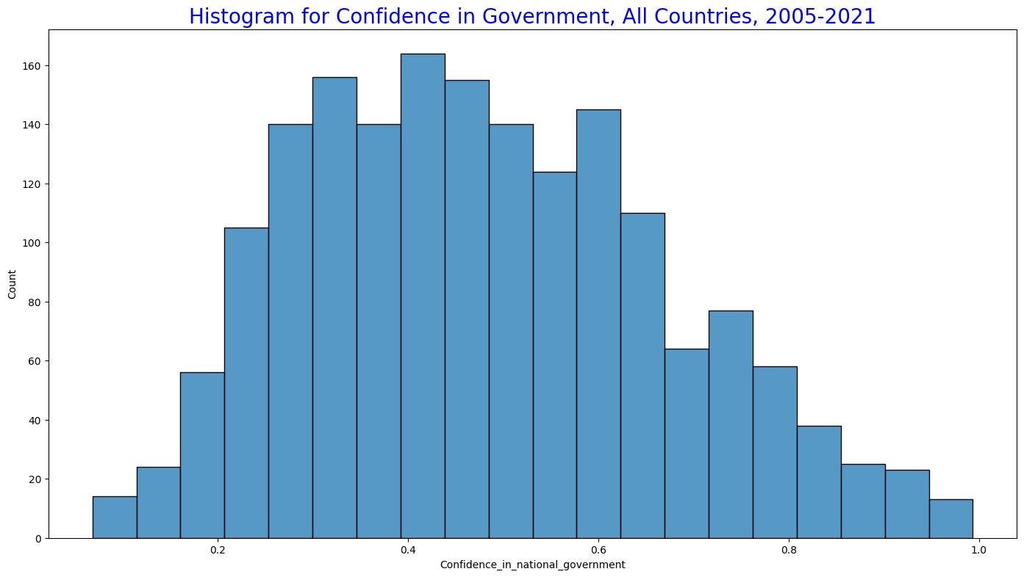

to the

rest of the world as well as within Europe. Although it is by now a well known notion, it is comforting to see that the data supports the common idea that Scandinavians are

amongst the happiest people. Analyzing why that is, would be beyond the scope of this paper, however, breaking down their cultural values and traditions might uncover some ‘secrets’ to Happiness.

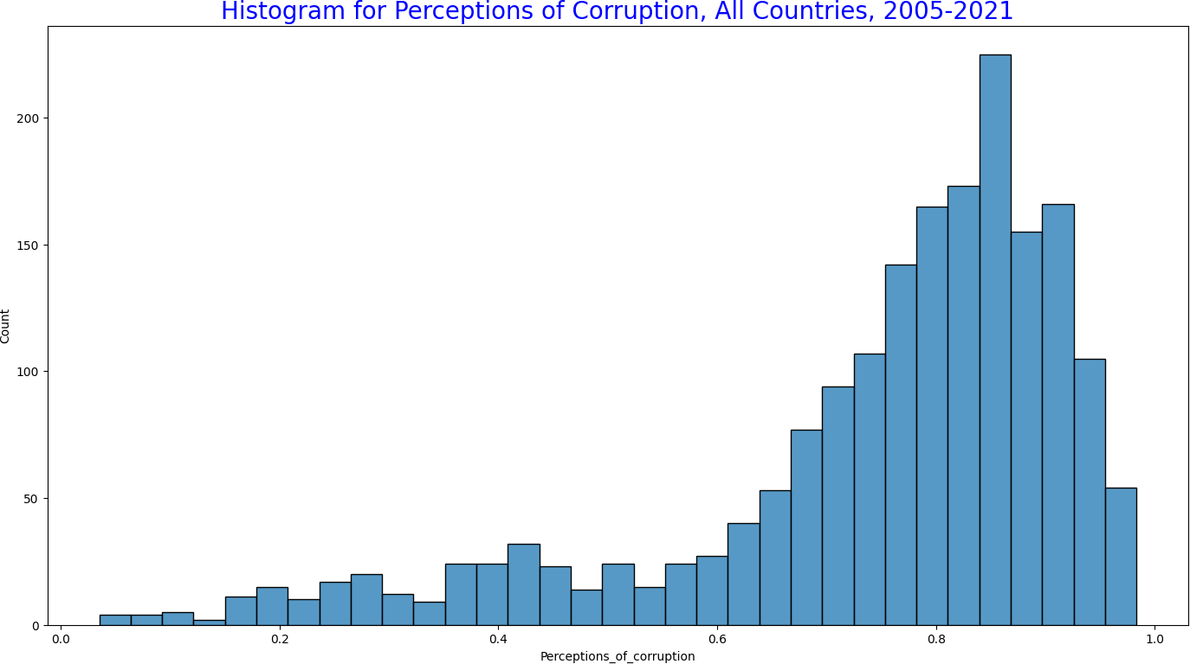

Figure 14 and Figure 15 go hand in hand as both WHR questions are strictly



related to the Government. One can assume that if perceptions of corruption were to be high, then confidence in government would be low, and together they might paint a

complete square if their graphs were overlapped. Figure 14 and 15 do support this notion quite strongly as perceptions of

corruption are between 0.7 and 1.0, while confidence in government is between 0.2

and 0.6. Clearly there is *some* inconsistency but the trend is still extremely interesting to note.

# Hypothesis Testing

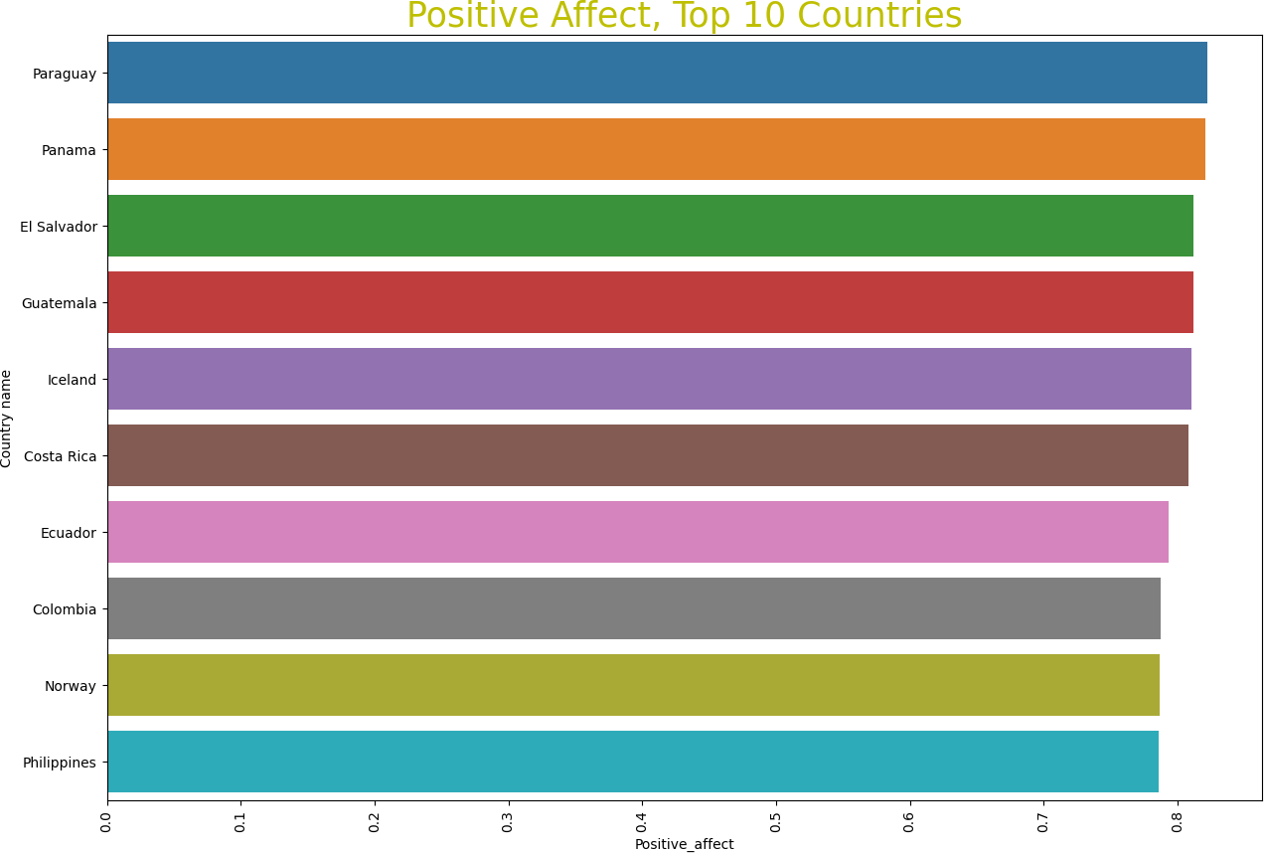

* **Hypothesis**: Null Hypothesis: The Happiness Index of a country is

strongly correlated with the GDP of a country in a positive linear fashion.

* **Null Hypothesis**: The Happiness Index of a country has no correlation with the growth of GDP of a country.
* This hypothesis was tested on

Denmark as it averaged the highest Happiness Score.

Lastly, this final figure is a curious case for what exactly Happiness is and also highlights some of the weaknesses within the study. When metric of measurement is positive affect, only Iceland and Norway

remain of the happiest countries, the rest are predominantly South American countries.

Positive affect is measured as an average score of the response to the following questions “*Did you experience*

*the following feelings during a lot of the day yesterday?*”14 and “*Did you learn or do something interesting yesterday?*”15 A

strong argument could be made for the fact that the answers to these questions provide just as much of an indication for Happiness as the index score. What is to say Happiness is not entirely one’s emotional experiences?

* **Pearson’s Correlation Coefficient**:

**-0.167**, weak negative correlation; as growth of GDP increases, happiness decreases slightly

* **P-value**: **0.5362**, the relationship presented is statistically insignificant, the null hypothesis is accepted
* **Conclusion**: The myriad number of factors influencing the ‘Happiness Index’ of a country are too many to count by hand, not to mention how different cultures weigh economic, political and social factors differently, as well as the subjective

nature of ‘happiness’ itself combined with an extremely simple questionnaire, with room for

significant subjective prejudice, means that it is nearly impossible to accurately measure a country’s happiness.

14 Helliwell et al.

15 Ibid

# References

Castle, Stephen, and Steven Erlanger. “E.U. Approves Brexit Extension, but Chaotic Departure Still Looms.” *The New York Times*, The New York Times, 21 Mar. 2019, [https://www.nytimes.com/2019/03/21/world/](https://www.nytimes.com/2019/03/21/world/europe/brexit-extension-eu-uk.html) [europe/brexit-extension-eu-uk.html](https://www.nytimes.com/2019/03/21/world/europe/brexit-extension-eu-uk.html).

Coltart, Cordelia E M et al. “The Ebola outbreak, 2013-2016: old lessons for new epidemics.” *Philosophical transactions of the Royal Society of London. Series B, Biological sciences* vol. 372,1721 (2017):

20160297. doi:10.1098/rstb.2016.0297

Data source: Helliwell, John F., et al. “World Happiness Report 2022.” *The World Happiness Report*, 18 Mar. 2022, [https://worldhappiness.report/ed/2022/#appe](https://worldhappiness.report/ed/2022/#appendices-and-data) [ndices-and-data](https://worldhappiness.report/ed/2022/#appendices-and-data). *Data for Table 2.1*

Helliwell, J. F., Layard, R., Sachs, J. D., De Neve, J.-E., Aknin, L. B., & Wang, S. (Eds.). (2022). World Happiness Report 2022. New York: Sustainable Development Solutions Network.

History.com Editors. “Boston Marathon Bombing.” *History.com*, A&E Television Networks, 28 Mar. 2014, [https://www.history.com/topics/21st-century](https://www.history.com/topics/21st-century/boston-marathon-bombings)

[/boston-marathon-bombings](https://www.history.com/topics/21st-century/boston-marathon-bombings).

“FAQ.” *Home*,

<https://worldhappiness.report/faq/>.

“Hong Kong Protests: Updates and Latest on City's Political Unrest.” *CNN*, Cable News Network, 1 Aug. 2019, [https://www.cnn.com/specials/asia/hong-kon](https://www.cnn.com/specials/asia/hong-kong-protests-intl-hnk) [g-protests-intl-hnk](https://www.cnn.com/specials/asia/hong-kong-protests-intl-hnk).

“In U.S., Poor Life Ratings Reach Record High.” *Gallup.com*, Gallup, 31 Oct. 2022, [https://news.gallup.com/poll/397286/poor-lif](https://news.gallup.com/poll/397286/poor-life-ratings-reach-record-high.aspx) [e-ratings-reach-record-high.aspx](https://news.gallup.com/poll/397286/poor-life-ratings-reach-record-high.aspx).

“President Donald Trump Impeached.” *History.com*, A&E Television Networks, 5 Feb. 2020,

[https://history.com/this-day-in-history/presid](https://history.com/this-day-in-history/president-trump-impeached-house-of-representatives) [ent-trump-impeached-house-of-representativ](https://history.com/this-day-in-history/president-trump-impeached-house-of-representatives) [es](https://history.com/this-day-in-history/president-trump-impeached-house-of-representatives).

“Syrian Civil War Fast Facts.” *CNN*, Cable News Network, 11 Apr. 2022, [https://www.cnn.com/2013/08/27/world/mea](https://www.cnn.com/2013/08/27/world/meast/syria-civil-war-fast-facts/index.html) [st/syria-civil-war-fast-facts/index.html](https://www.cnn.com/2013/08/27/world/meast/syria-civil-war-fast-facts/index.html).

“The Psychological Effects of TV News.” *Psychology Today*, Sussex Publishers, [https://www.psychologytoday.com/us/blog/](https://www.psychologytoday.com/us/blog/why-we-worry/201206/the-psychological-effects-tv-news) [why-we-worry/201206/the-psychological-ef](https://www.psychologytoday.com/us/blog/why-we-worry/201206/the-psychological-effects-tv-news) [fects-tv-news](https://www.psychologytoday.com/us/blog/why-we-worry/201206/the-psychological-effects-tv-news).